**Neil Patrick Del Gallego**

**ALDP Module 1 Reflection Paper**

Note to reader: This reflection paper supports **augmented reality**. The figures presented herein can be scanned using the application provided for you. A successful scan will show a rendered object in the application. The object can be rotated by swiping left or right. The augmented-reality application needs your device camera and good lighting.

**My Beginning Journey as a Lasallian Teacher**

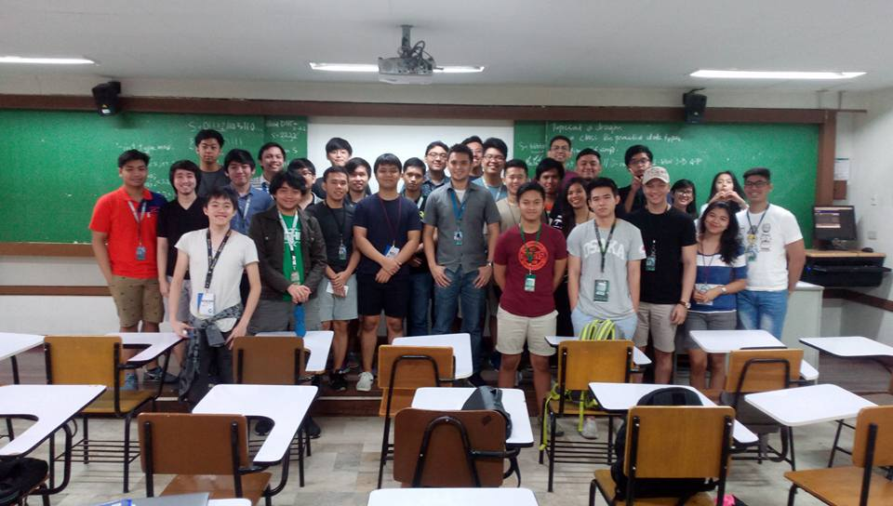

Figure 1: One of the first classes I taught

I would like to share to the reader, how I decided to pursue a career in the academe. My industry experience was a roller coaster, especially coming from the local game development industry. I worked at Anino Playlab Inc., which was formerly Anino Games Inc. The gaming industry here in the PH is young, growing, and full of opportunities. At the same time, the demand for it is volatile, which I have experienced being part of a company where we financially struggled. I experienced one of the worst that could happen on my career, which at any time, I could easily lose the job that I always wanted to do. I was very thankful for my employer that they decided to keep me, and I also decided to stay with my company until I earned my MS degree.

Despite the struggles, deciding to stay in Anino was one of the best decisions I have made in my life. The 5 years of industry experience has really improved my technical skills, as well as having a broader understanding of how the industry functions, in and out. I got to experience great ownership of projects we made, because whatever I do, really matters for the company. During the dark times of Anino, the games that we develop, would really make or break the company. The top skill that I acquired from my industry experience, which I always tell my students that I handle, is that “quality is worth killing for.” I always tell my students that they should have ownership of what they do in their projects, and spend time to actually test their systems so their work can be perfected. Figure 1 shows one of my first classes that I have taught (ALGOCOM – Algorithm Complexity), and the students who were considerate to adjust and adapt to my teaching style. I believe they were shocked by my standards. But fortunately, majority of the classes I handled got a higher than average mark.

My first ALDP session started with the Reims experience, as seen in Figure 2. When Fr. Nelson has briefed us about ALDP and how long its duration (5 terms!). I was at first, intimidated. I also hear from my co-faculty members who finished ALDP that it eats up their time, and occasionally, they bring papers with them that they check during seminars. This is in fact, what I did, as seen in Figure 3, where Br. Jun has introduced as the story of St. La Salle. 😊 But that doesn’t mean I did not learn anything after the seminar! In fact, one important aspect that I have learned during this session, and from the Reims experience, is the philosophy of St. La Salle. I understood that every student that we teach, should be guided and nurtured as they progress through their journey. This is what I observed when I was studying in De La Salle University. My teachers (now who are my co-faculty members), have been nurturing and has guided me throughout my journey in my BS and MS years.

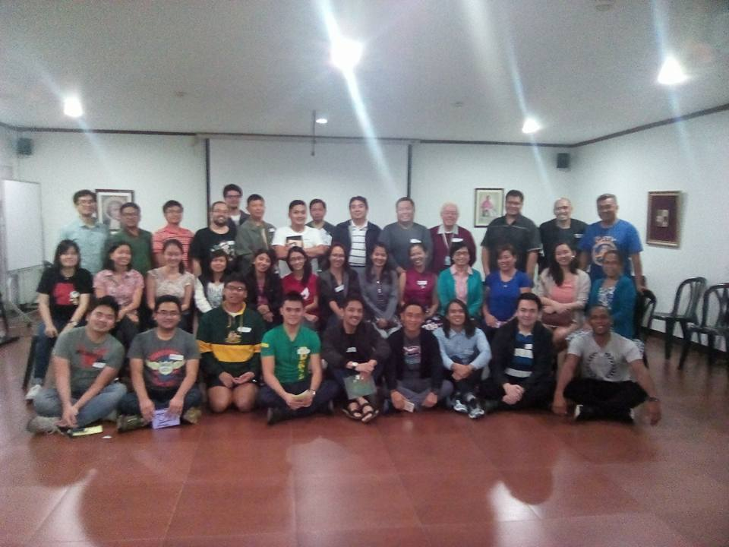

Figure 2: The ALDP Batch X1

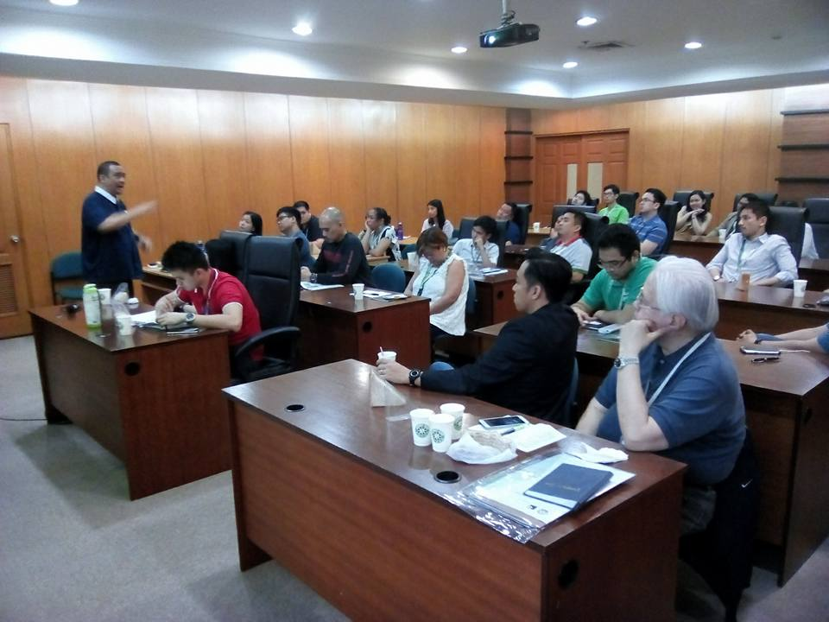

Figure 3: Br. Jun introducing St. La Salle and his story as a founder

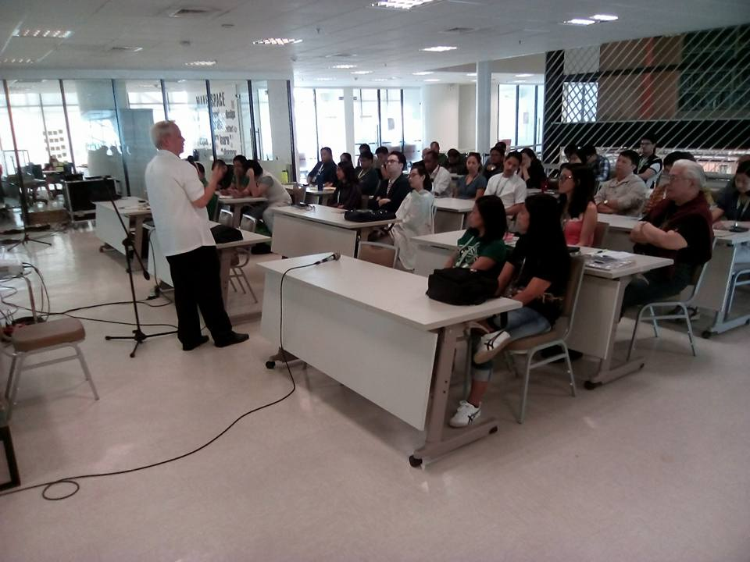

Figure 4: Br Vic discussing St. La Salle as a teacher

In Figure 4, Br. Vic has taught the faculty members about the characteristics of a Lasallian school. There are 7 characteristics of a Lasallian school, present in his slides, and would no longer be enumerated here. To relate to all of the discussion that transpired in this session, one aspect that I find challenging, and will be challenged throughout my career in teaching, is having to pay attention to the uniqueness of each student. Even Br. Vic mentioned that this characteristic is difficult to perform. In fact, I had already faced difficulties on this matter in my 2nd term of teaching. One of my WEBTECH (Web Technologies) classes has a full size of 43 students, and in a large computer lab! Throughout the term, it was difficult to teach the whole class as they were noisy and a handful of them were challenged by the topics I have taught them. The performance of the class was towards the extreme. There were a handful of students who are so fast in picking up the lessons, while other students encountered difficulties in understanding the topics, several times. The solution I found effective during the term, is to give the materials at the start of the lecture to all students, so those who were faster, can do advanced reading and activities. It was also effective to provide “pitstops” at certain points in the lectures, where bright students can do the activity to earn bonus points, while I teach the lecture at a regular pace for all the students to understand.

In the session of Lasallian Pedagogy, which was conducted by Sr. Cora (no pictures though), Sr. Cora has mentioned that majority of us were in the “Spring” part of life, where we want to focus on being successful in our career and reaching our full potential. I have to fully agree with this, as I am just starting in the academe career, transitioning from industry. One of our activities were to ask ourselves about our decision why we chose to teach in DLSU. First, I’d like share to the reader, what our Playlab CEO (Jakob Lykegaard) has envisioned for our company. He mentioned to us about his manner of promotion in our company, which all boils down to having an “impact level.” Any employee in Playlab will have an impact level from 1 – 5. It is categorized as follows:

* Impact Level 1 – the employee displays positive attitude and work ethic on a personal level. Tasks are being submitted on time and with acceptable quality. It meets the expectation of what the team has agreed upon.
* Impact Level 2 – The employee constantly impacts or influences his department, by improving their productivity or adding additional value to their work output. For example, a game developer may have created reusable design patterns or classes that other developers can use to speed up their development. A game developer may have created training materials for interns or he constantly conducts trainings or workshops for the department.
* Impact Level 3 – The employee’s influence is interdisciplinary. He impacts how other departments work. For example, a game developer may have created automation tools to speed up the task of the QA department. A game developer may have created a tool to empower game designers to edit or invent game mechanics through an editor tool.
* Impact Level 4 – The output of the employee has a direct impact on company revenue. For example, a game developer and a game designer has implemented a feature that boosts the amount of daily active users, which eventually leads to boost of sales.
* Impact Level 5 – The output of the employee has a direct impact to the gaming industry. He/she is a known icon in the community, and is the face of the company. His/her work has influenced other gaming companies. For example, the game designer who created very successful games like Starcraft, has impacted the gaming industry. In Playlab, no one has reached this level yet.

The “impact level” philosophy, has greatly inspired me. It is a matter of creating a positive impact to your peers, to the community, and to the world! For me, it is the most fulfilling role that I want to accomplish. This is the main motivation why I decided to pursue a long-term career in the academe, where I want to have a positive impact to my students, to make them industry-ready, to have a positive impact to the community, by publishing research and collaborating with other researchers, and to eventually have a positive impact to the world, by contributing to the body of knowledge through scientific research.

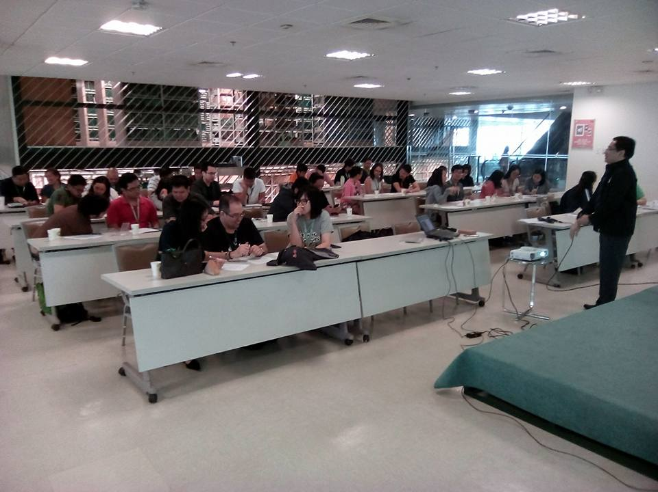

Figure 5: Dr. Mistades about to prepare for his module.

The last two modules were conducted by Dr. Mistades, seen in Figure 5 and Dr. Prudente, which really helped me realize the importance of learning and adjusting to the styles of students. In the module of Dr. Mistades, we had the “Lost at Sea” activity which was an activity on how you make decisions as an individual, with a partner, then as a group. While Dr. Mistades did not mention directly, the relationship of this activity in the module, I believe that it was for us to realize that knowledge and learning can be influenced by your fellow peers. It is also observed in our activity, that we managed to get a better score, if we were to work as group, rather than working alone. This learning is something I can take note of, when I teach to students. Towards the later part of this module, Dr. Mistades mentioned the sources of learning. As an instructor, I have learned in that topic, that I should utilize all sources of learning for the students, to maximize the learning outcomes.

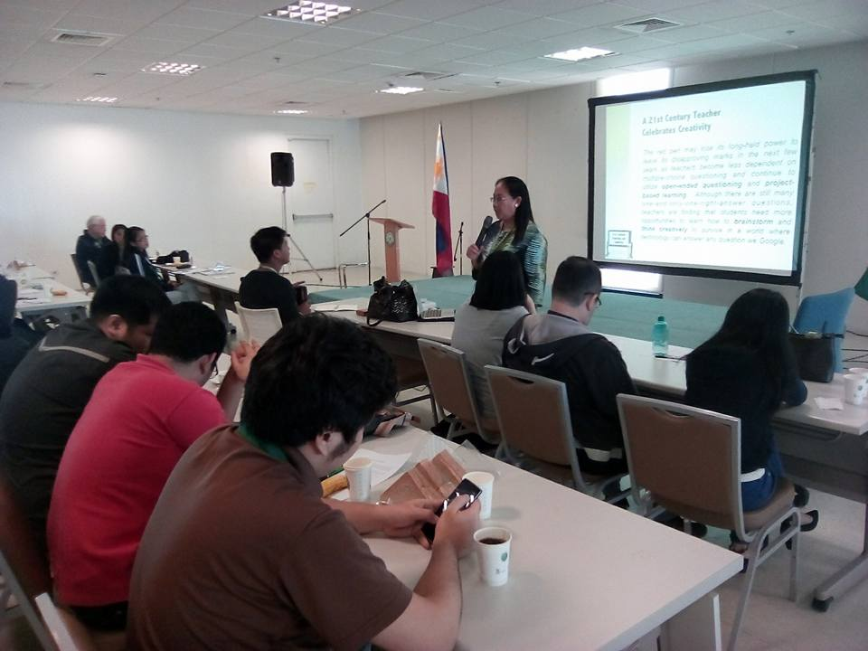

Figure 6: Dr. Prudente discussing 21st century learners

The module of Dr. Prudente is all about the 21st century learners. I have to completely agree that there is already a gap between the students and the instructors. The students (or so-called millennials) now embrace technologies, and their culture should be embraced by the instructors. As of this time, I am comfortable with how I teach my students, and students were also vocal on how they admire my teaching style. The teaching feedback I have received from my first term in teaching were heartwarming. Some students have pointed out that they just go to class because the environment in my lectures is very conducive for learning. They go to class, not because out of requirement, but because I have inspired them to learn and make the subject matter interesting. I hope I can make this style consistent for the rest of my teaching career.

For the concluding remarks, I would like to mention what Dr. Yamie has mentioned during our first session in ALDP. She stated that ALDP is divided into multiple seminars and its main goal is to know if we will find a home here in the Lasallian community. Throughout the ALDP journey, we would hopefully realize the importance of Lasallian teaching, and embrace the philosophies and culture in DLSU. After completing the module 1 of ALDP, I believe that I am on the right place. I want to pursue a career in the academe as a long-term goal, probably until the rest of my life. I am enjoying every moment of it so far.